User Acceptance Testing (UAT) Template
Date | 28-10-2026
Team ID | SWUID2026402568
Project Name | HotelPro - Complete hotel booking and management solution

Project Overview:
Project Name: HotelPro Management System
Description: A comprehensive web-based hotel management platform designed to automate hotel operations. It features guest registration, real-time room availability, room booking management, check-in/check-out tracking, housekeeping status, automated bill generation, and admin reporting.
Project Version: v1.0.0
Testing Period: 2026-11-01 to 2026-11-10
Testing Scope:
- User registration, login, and role-based authentication
- Room discovery, filter by category/dates, and real-time availability check
- Room booking flow and online payment gateway integration
- Staff dashboard for check-in, check-out, and guest record lookup
- Housekeeping status update (Cleaned, Dirty, In Service)
- Billing generation, discount application, and receipt printing
- Search and filter functions across bookings and room inventories
- Managerial analytics reports (Occupancy rate, revenue generation)
Requirements to be Tested:
- As a guest, I want to search and reserve rooms online seamlessly.
- As a guest, I want to receive instant booking confirmation and payment receipt.
- As a receptionist, I want to check guests in/out efficiently and generate invoices.
- As a housekeeper, I want to update room status in real-time.
- As a hotel manager, I want to monitor room occupancy and total revenue.
Testing Environment:
URL: https://hotelpro.example.com
Credentials:
- Guest User: guest@example.com / Guest123
- Receptionist: staff.reception@example.com / Staff123
- Hotel Admin: admin@example.com / Admin@123
Test Cases:
Test Case ID | Test Scenario | Test Steps | Expected Result | Actual Result | Pass/Fail
TC-001 | User Registration | 1. Visit site  2. Click 'Sign Up'  3. Fill & submit form | User account created successfully | Account created, redirected to guest dashboard | Pass
TC-002 | Room Booking (Guest) | 1. Search dates & room type  2. Select room & click Book  3. Complete checkout | Booking confirmed and booking ID generated | Room status updated to Booked, email receipt sent | Pass
TC-003 | Guest Check-In (Staff) | 1. Log in as Receptionist  2. Find booking ID  3. Click 'Check-In' | Room status becomes 'Occupied' | Guest checked in, key assigned successfully | Pass
TC-004 | Housekeeping Update | 1. Log in as Staff  2. Select Room 102  3. Set status to 'Cleaned' | Room status updates to 'Available' | Room status reflected as Available across system | Pass
TC-005 | Bill Generation & Check-Out | 1. Select occupied room  2. Click 'Check-Out & Bill'  3. Process payment | Itemized bill generated and room freed | Invoice printed, room status changed to 'Dirty' | Pass

Bug Tracking:
Bug ID | Bug Description | Steps to reproduce | Severity | Status | Additional feedback
BG-001 | Error on booking form when selecting past check-out date | 1. Select check-in today  2. Select check-out yesterday  3. Submit form | Medium | Resolved | Added client-side date validation constraint
BG-002 | Total calculation discrepancy on multi-room booking | 1. Select 2 Deluxe rooms  2. Apply discount code  3. Proceed to bill | High | Closed | Recalculated tax and discount logic in API backend

UAT Process Lifecycle Diagram:
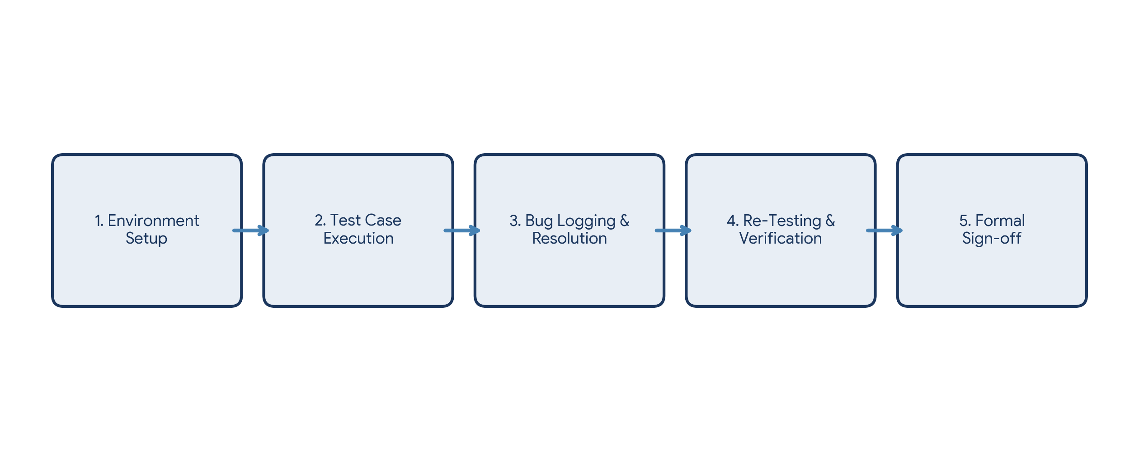
Sign-off:
Tester Name: Chhavi Jain
Date: 28-10-2026
Signature: Chhavi Jain
Notes:
• Ensure that all test cases cover both positive and negative scenarios.
• Encourage testers to provide detailed feedback, including any suggestions for improvement.
• Bug tracking should include details such as severity, status, and steps to reproduce.
• Obtain sign-off from both the project manager and product owner before proceeding with deployment.

